Hello everyone!!!  
  
"Thrilled to share my Power BI dashboard on OTT Dashboard Analysis 📊✨ Making use of data cleaning, meticulous processing, and insightful with slicers, I've crafted a dynamic dashboard."  
  
Simple Insights:  
(I) Netflix:  
1. 15k Total shows are available on Netflix.  
2. Total movies are 11.7k and Total series are 3783 out of the 15k shows.  
3. The average IMDb Score is 6.50.  
4. Most of the show durations are between 1-2 hours followed by <30 minutes.  
5. In 2020, most shows are released followed by 2015.  
6. More movies and series received awards in 2015.  
  
(II) Amazon Prime:  
1. 9684 shows are available to watch on Amazon Prime.  
2. 7814 Movies and 1854 Series are their.  
3. Amazon Prime content is available in 87 countries.  
4. 4 Slicers are available in the dashboard to know the insights.  
  
(III) Disney+ Hotstar:  
1. 1450 shows are available to watch on Amazon Prime.  
2. 1052 Movies and 398 Series are their.  
3. In 2019, most shows are released followed by 2020.  
4. 519 distinct listing are listed on Disney+ Hotstar.  
  
📈 Data Analysis Highlights:  
Develop interactive dashboards and reports to visualize essential metrics .  
Utilize Power BI's visualization tools to create charts, graphs, and tables representing viewership trends, popular content, user demographics, etc.  
  
🎓 Project Learning:  
Gained expertise in data analysis techniques, with a specialization in time OTT Dashboard Analysis. Delivered tangible results, including valuable insights and the creation of interactive dashboards.  
Excited to discuss more about this project and explore opportunities to apply these skills to drive success in future endeavors!  
  
[#dataanalysis](https://www.linkedin.com/feed/hashtag/?keywords=dataanalysis&highlightedUpdateUrns=urn%3Ali%3Aactivity%3A7151073694872649729) [#dataanalytics](https://www.linkedin.com/feed/hashtag/?keywords=dataanalytics&highlightedUpdateUrns=urn%3Ali%3Aactivity%3A7151073694872649729) [#datavisualization](https://www.linkedin.com/feed/hashtag/?keywords=datavisualization&highlightedUpdateUrns=urn%3Ali%3Aactivity%3A7151073694872649729) [#powerbi](https://www.linkedin.com/feed/hashtag/?keywords=powerbi&highlightedUpdateUrns=urn%3Ali%3Aactivity%3A7151073694872649729) [#dashboard](https://www.linkedin.com/feed/hashtag/?keywords=dashboard&highlightedUpdateUrns=urn%3Ali%3Aactivity%3A7151073694872649729) [#data](https://www.linkedin.com/feed/hashtag/?keywords=data&highlightedUpdateUrns=urn%3Ali%3Aactivity%3A7151073694872649729) [#visualization](https://www.linkedin.com/feed/hashtag/?keywords=visualization&highlightedUpdateUrns=urn%3Ali%3Aactivity%3A7151073694872649729) [#job](https://www.linkedin.com/feed/hashtag/?keywords=job&highlightedUpdateUrns=urn%3Ali%3Aactivity%3A7151073694872649729) [#dataanalystjobs](https://www.linkedin.com/feed/hashtag/?keywords=dataanalystjobs&highlightedUpdateUrns=urn%3Ali%3Aactivity%3A7151073694872649729) [#ott](https://www.linkedin.com/feed/hashtag/?keywords=ott&highlightedUpdateUrns=urn%3Ali%3Aactivity%3A7151073694872649729) [#ottdashboardanalysis](https://www.linkedin.com/feed/hashtag/?keywords=ottdashboardanalysis&highlightedUpdateUrns=urn%3Ali%3Aactivity%3A7151073694872649729)  
[#projectcompletion](https://www.linkedin.com/feed/hashtag/?keywords=projectcompletion&highlightedUpdateUrns=urn%3Ali%3Aactivity%3A7151073694872649729)

Activate to view larger image,

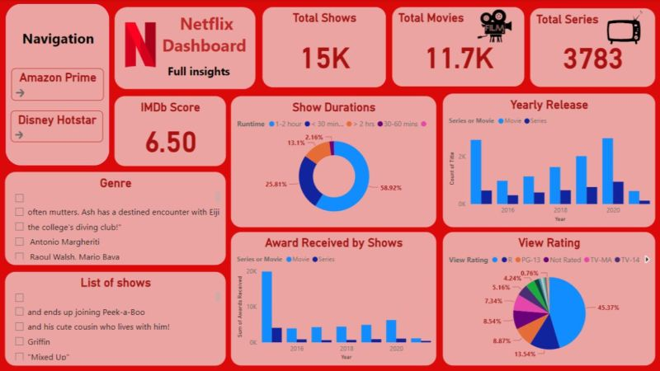

Activate to view larger image,

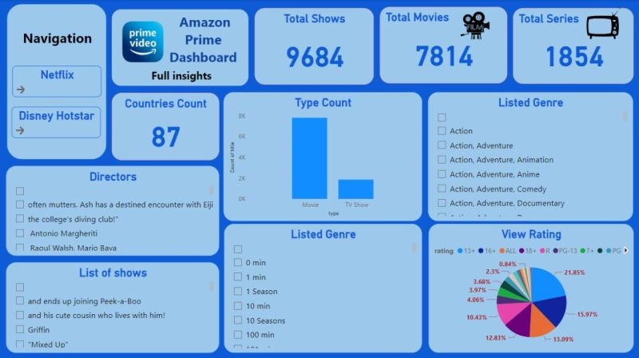

Activate to view larger image,

